
FAKE NEWS DETECTION

Submitted by:
GOVIND TIWARI
ACKNOWLEDGMENT
In preparation of my assignment, I had to take the help and guidance of some respected persons, who deserve my deepest gratitude& lot of internet research papers from various blogs and research publication. As the completion of this assignment gave me much pleasure, I would like to show my gratitude my mentors from Flip Robo Technologies for giving me a good guidelines for assignment throughout numerous consultations. I would also like to expand my gratitude to all those who have directly and indirectly guided me in writing this assignment.

INTRODUCTION

Business Problem Framing
To distinguish between Real News and Fake news
Conceptual Background of the Domain Problem
The authenticity of Information has become a longstanding issue affecting businesses and society, both for printed and digital media. On social networks, the reach and effects of information spread occur at such a fast pace and so amplified that distorted, inaccurate, or false information acquires a tremendous potential to cause real-world impacts, within minutes, for millions of users. Recently, several public concerns about this problem and some approaches to mitigate the problem were expressed.

Motivation for the Problem Undertaken
In the present era, numerous amounts of information are generated every day amid advancement of electronic devices and social media, and among such information, false information, called fake news, exists as well. Fake news creates various problems in our society, and endeavours are required to solve them. Accordingly, many researchers have conducted studies to detect rumours and fake news by using Twitter data, one of the popular social media outlets.
Review of Literature
For this report, we are exploring the field of natural language processing, which is the broad study of how computers and machines can understand human to human communication and how texts are analyzed based on contextual information by machines.
In particular, we are using natural language processing to classify news articles as real news or “fake news”. Fake news is misinformation masked under the guise of a real news article, and is used to deceptively influence people’s beliefs.For this report, we are classifying news articles as “real” or “fake”, which will be a binary classification problem - classifying the samples as a positive (with fake news) or negative (not fake news) sample

Data collection and Preprocessing
The data is give directly by our mentores.The size of the data is 124800 and the shape is (20800*6)

Mathematical/ Analytical Modeling of the Problem
By using the information collected and preprocessed, statistical analysis was performed to find the best features of fake news, and the results were visualised in boxplots, the features representing the differences visually between the fake news and the real news by using the boxplots.
Hardware and Software Requirements and Tools Used
we are using python language for interpreting the data and read from pandas and numpy libraries
there are also more other libraries which can be helpul to work along with this assignment.
from sklearn.model_selection import train_test_split
import pandas as pd
import numpy as np
from pprint import pprint
import matplotlib.pyplot as plt
import seaborn as sns
from sklearn.feature_extraction.text import TfidfVectorizer
from sklearn.naive_bayes import MultinomialNB
from sklearn.model_selection import train_test_split
from sklearn.metrics import accuracy_score, confusion_matrix, classification_report
from sklearn.feature_extraction.text import CountVectorizer
from sklearn.linear_model import LogisticRegression
from sklearn.feature_selection import RFE
from sklearn.model_selection import GridSearchCV
from sklearn.ensemble import RandomForestClassifier
from sklearn.svm import SVC
from sklearn.neighbors import KNeighborsClassifier
from nltk.sentiment.vader import SentimentIntensityAnalyzer
analyser = SentimentIntensityAnalyzer()
from collections import Counter
from nltk.corpus import stopwords
from nltk.tokenize import word_tokenize
import warnings
import string
import nltk
warnings.filterwarnings('ignore')

import matplotlib.pyplot as plt
from sklearn.metrics import classification_report, accuracy_score

Data Sources and their formats
the data is in csv format to upload and is done by pandas and numpy library to do so
Data Preprocessing Done
This section describes the preprocessing of the collected data for data analysis. As text information contained a variety of information, information extraction through text analysis was required. Therefore, URL information, special characters (hashtag, mention, question, emphasis), emphasised words, emotion information (number of positive/negative words, emotional score) were extracted from the text information, and the extracted information was saved in ‘text_info’. The NLTK package was used for the words and sentences expressing emotions in texts .

For the emotional score, a method used by count vectorizerwas used, that is, 1 point was assigned whenever a strong positive word was present in the text information and 0.5 point in the case of weak positive word. Likewise, −1 point was assigned for a strong negative word and −0.5 point for a weak negative word.
Data Distribution
We performed some data analysis on the text and wanted to understand how the text is distributed. We had analyzed and represented our data (text) distribution in a few different perspectives. We first analyzed the data through graphing its sentiment polarity .
We will be comparing the graphs before and after preprocessing, which includes, stop word removal, removing punctuation and special characters, and numbers

Sentiment Polarity
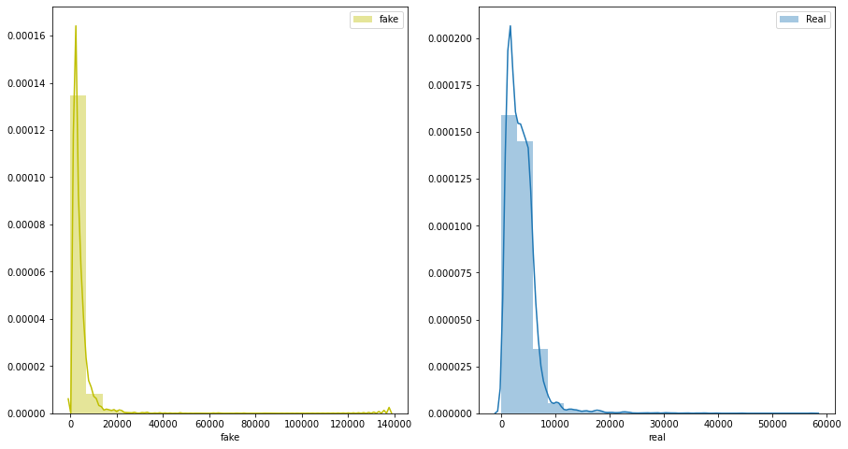
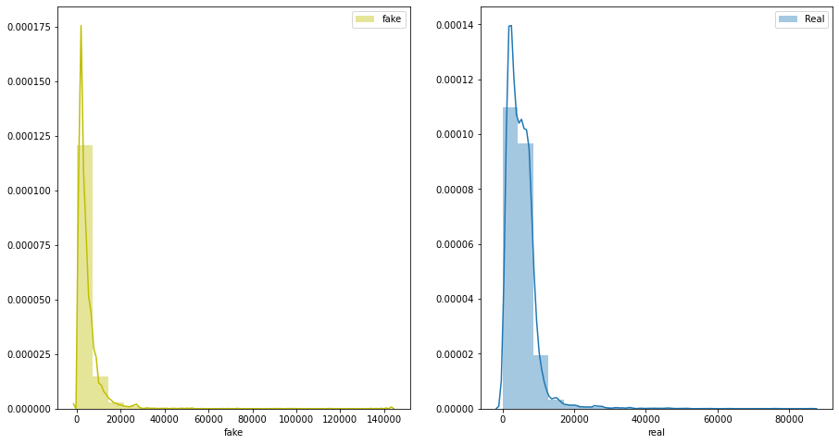
Model/s Development and Evaluation

Testing of Identified Approaches (Algorithms)
Random Forest
A random forest is an ensemble classifier that estimates based on the combination of different decision trees. So random forest will fit a number of decision tree classifiers on various subsamples of the dataset. A random best subsets are built by each tree in the forest. In the end, it gives the best subset of features among all the random subsets of features .
Logistic Regression
Logistic regression is a statistical machine learning algorithm that classifies the data by considering outcome variables on extreme ends and this algorithm is providing a discriminatory line between classes. Compared to another simple model, linear regression, which requires hard threshold in classification, logistic regression can overcome threshold values for a large dataset.

Support Vector Machine (SVM)
SVM is a supervised machine learning algorithm in which a hyperplane is created in order to separate and categorize features. The optimal hyperplane is usually calculated by creating support vectors on both sides of the hyperplane in which each vector must maximize the distance between each other. In other words, the larger the distance between each vector around the hyperplane, the more accurate the decision boundary will be between the categories of features .
Knn Model
The k-nearest neighbors (KNN) algorithm is a simple, supervised machine learning algorithm that can be used to solve both classification and regression problems. It's easy to implement and understand, but has a major drawback of becoming significantly slows as the size of that data in use grows.

- Run and Evaluate selected models

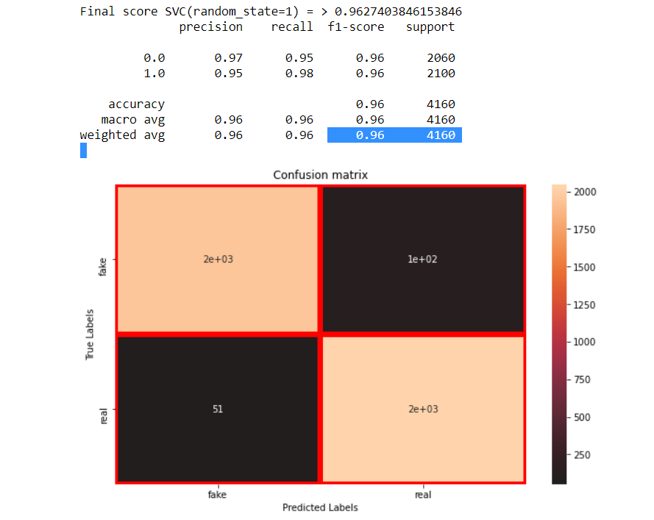

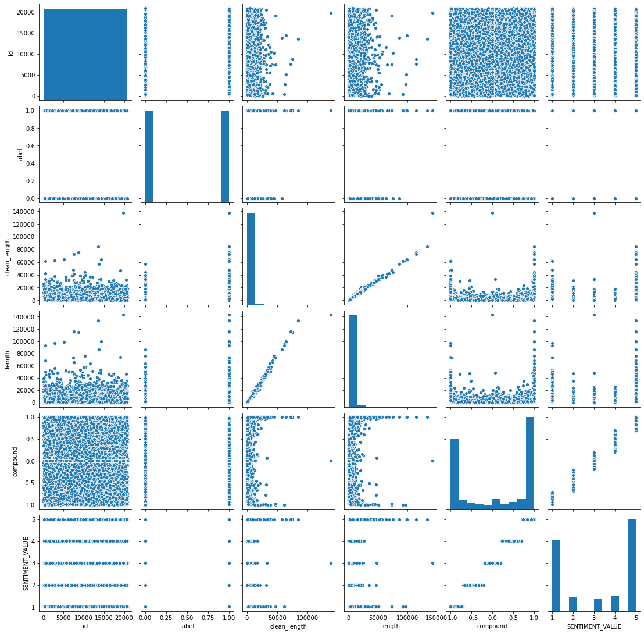
Key Metrics for success in solving problem under consideration

- Visualizations
By using the information collected and preprocessed statistical analysis was performed to find the best features of fake news, and the results were visualised in boxplots.The features representing the differences visually between the fake news and the real news by using the boxplots.

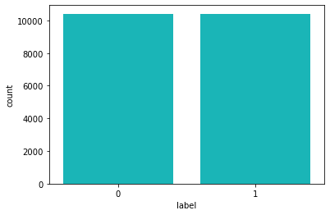

Matrix arrangment and Density PLot

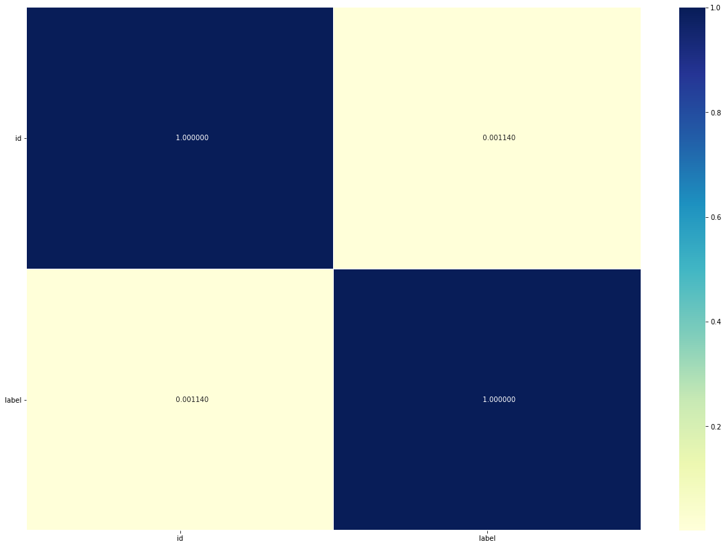
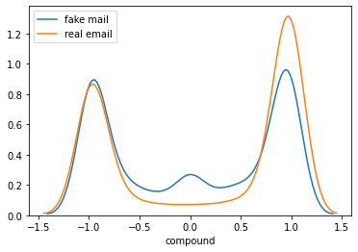

SVC SCORE

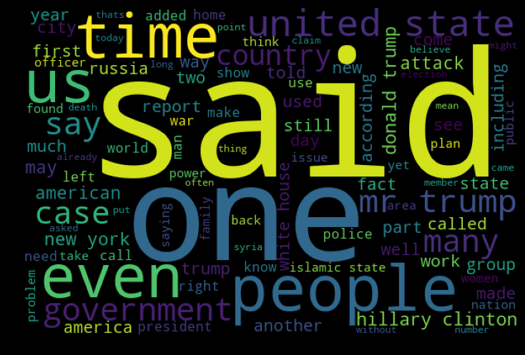

Negative Wordcloud

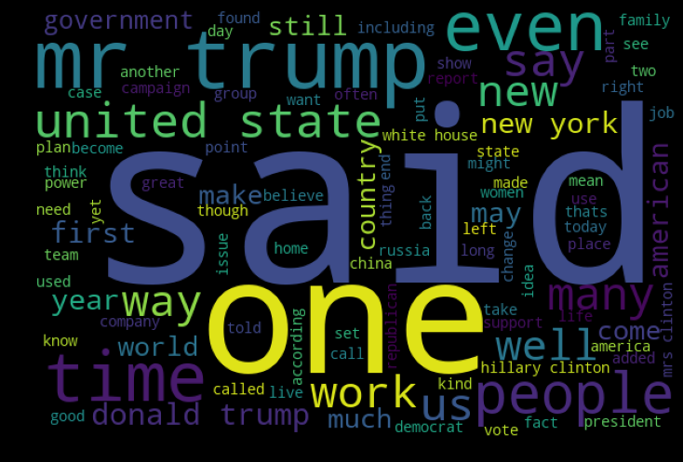
Positive Word Cloud

Data Stastics based On sentiments
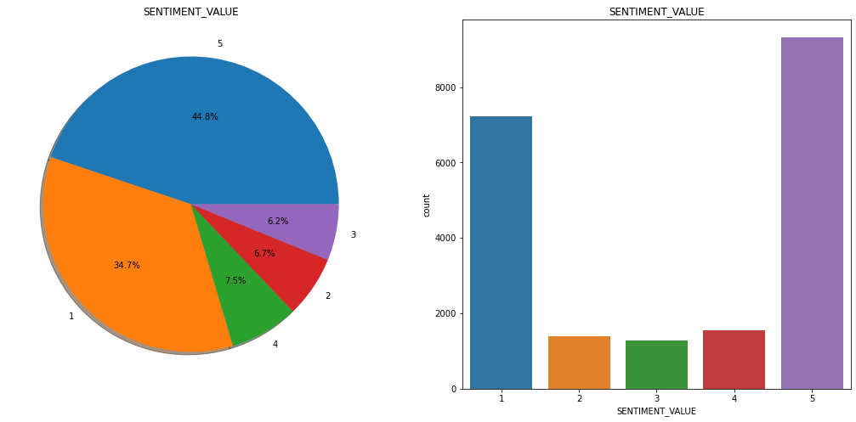
Comparison between Real and Fake alongwith Sentiments
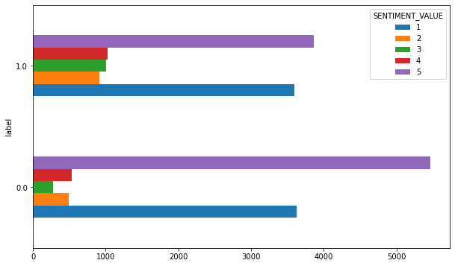

Sentiment based on real and fake distplot

Pairplot

Interpretation of the Results

#it shows the data has approximatley even out in fake and real email
#from above graph it ccan be interpreted the fake news generally have less length than the originally one ,In other words it can be conclude they may lack in deep fact knowledge and other important poins
#As from above graph it is shown in above graph that it quite hard to differentiate when the fake news is in Negative sense as it shows the same trend in real news ,although we can differentiate when the news is very positive or almost neutral**.
#It shows the data is either very positive or very Negative ,although the posive news is slightly more than the negative news
i#t shows the statstical data shows very positive news is greater thanvery negative news by approximatley by 10%.
#As from that word plot chart it says the news are in positive mood for the trump & government admnistration on other side henery clintopn and us police has very negative in news and other terms releated to russia and racial

CONCLUSION
This report provides a fairly simple approach to encode texts and how the presence of words in general impacts the classification of texts as real and fake. We achieved high accuracy results in most of our algorithms and in particular SVC generally do better than the others.

